**The way to use the program**

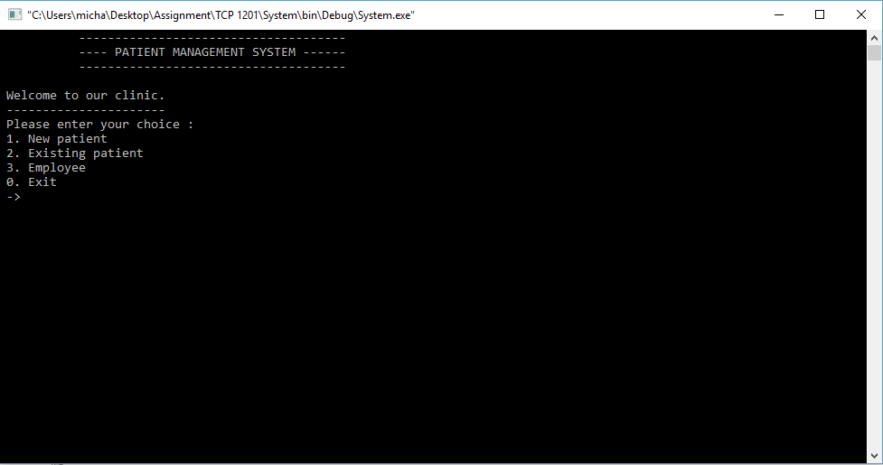

This is the main menu of my program.

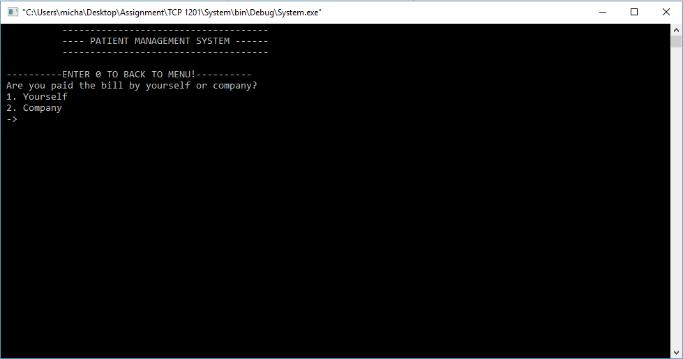

This is the new page for new patient. It will ask whether user paid by yourself or company before proceed to another page.

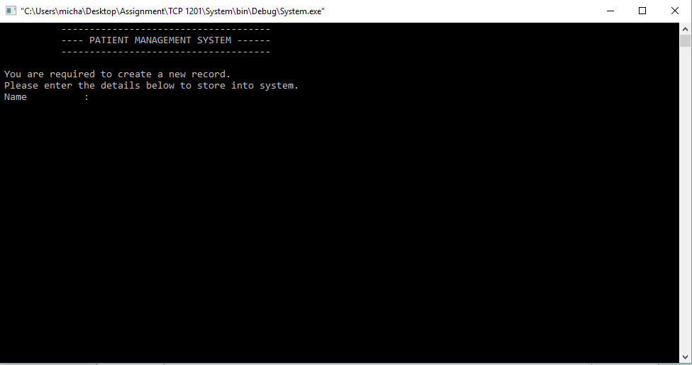

After user choose 1 (Paid by myself), user need to create a new record for new patient.

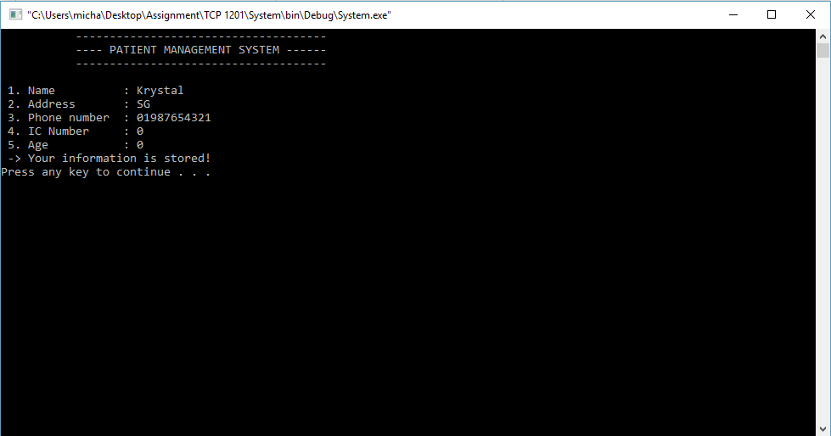

After user type the information, it will show again the information after done inserted the information. After press any key, it will jump back to menu.

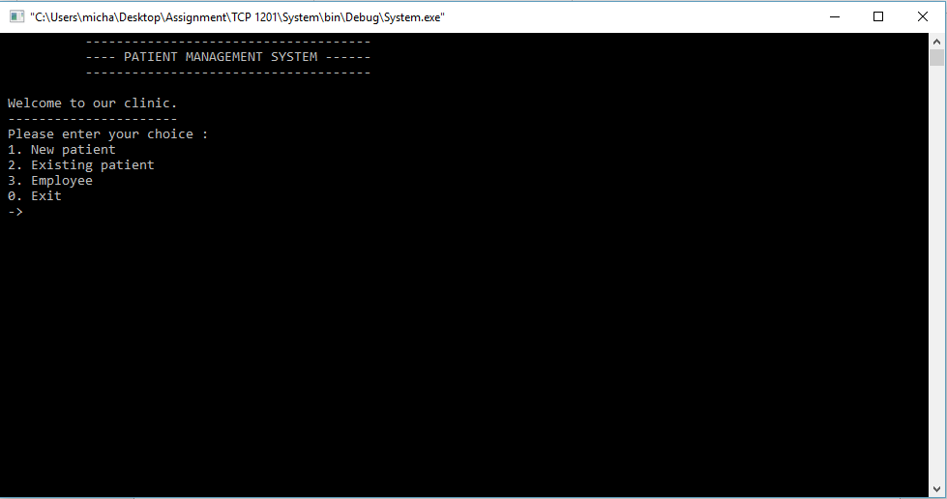

In this menu, choice 2 is selected. Below is the new page for choice 2.

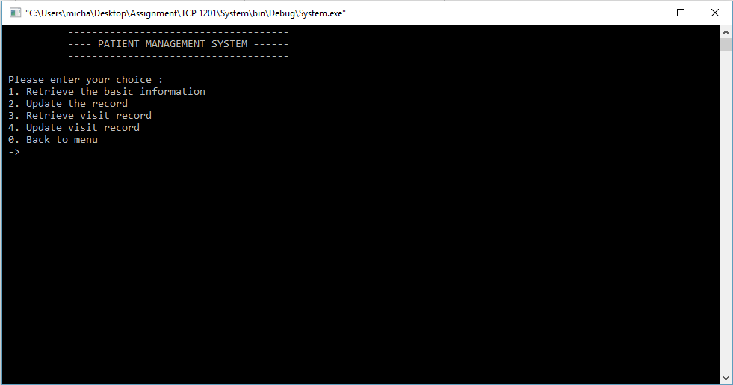

In this page, user will go to existing patient page.

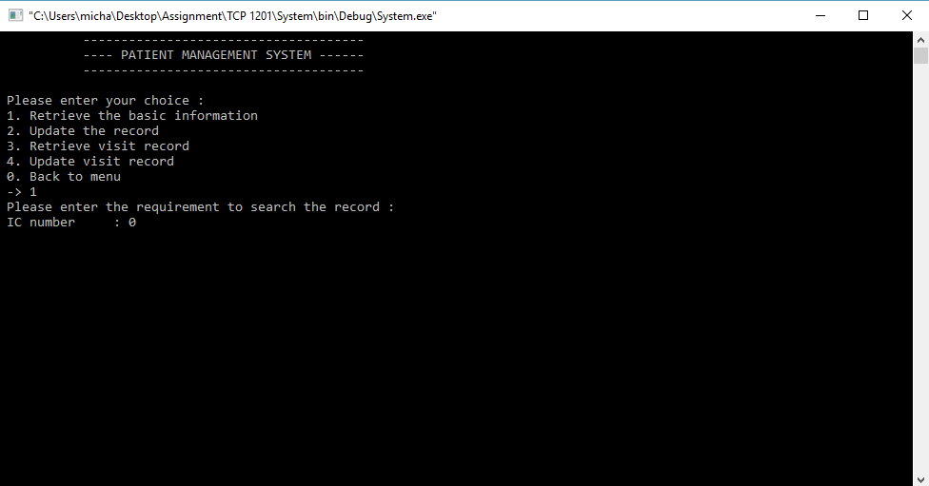

If user enter choice 1, user are required to type IC number to retrieve the basic information.

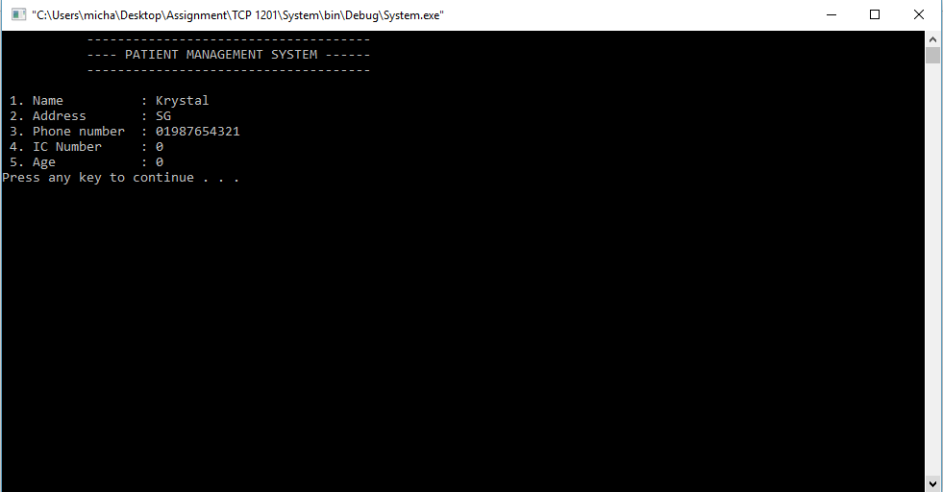

It will show the result of the IC number user insert.

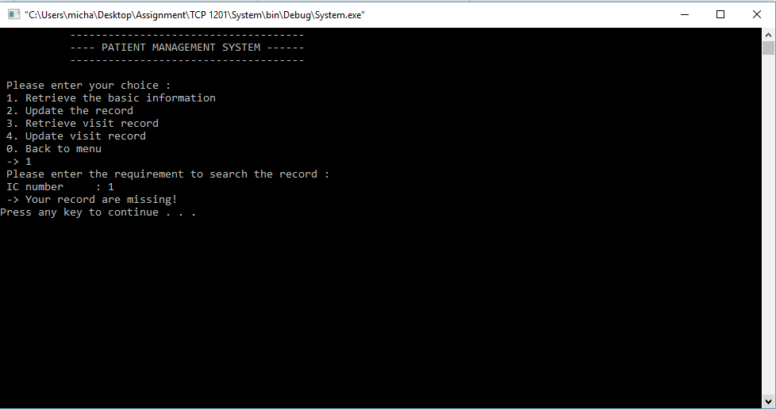If user inserted wrong IC number, it will show “your record are missing!”.

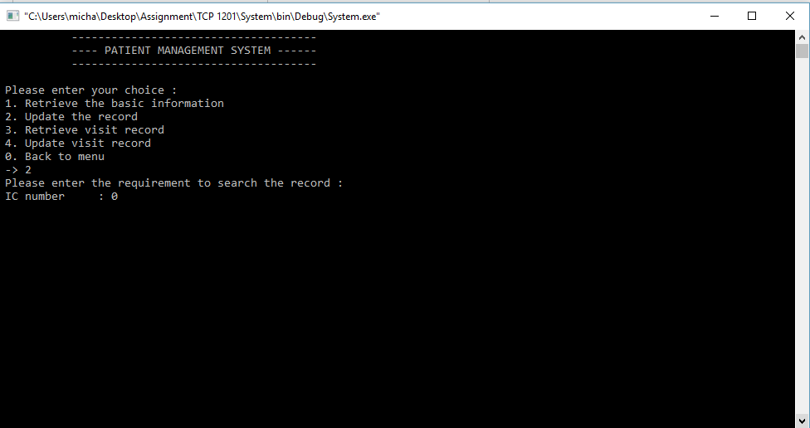

If user want to update the record, user are needed to type IC number to continue the process.

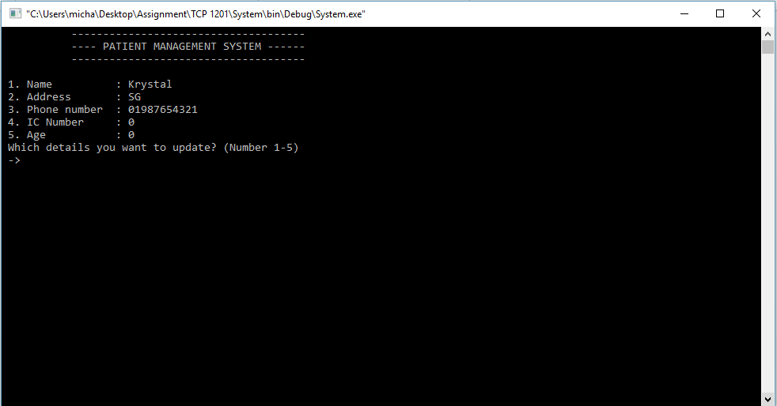

After user inserted correct IC number, it will show the result as above. User are freely to change any details user want.

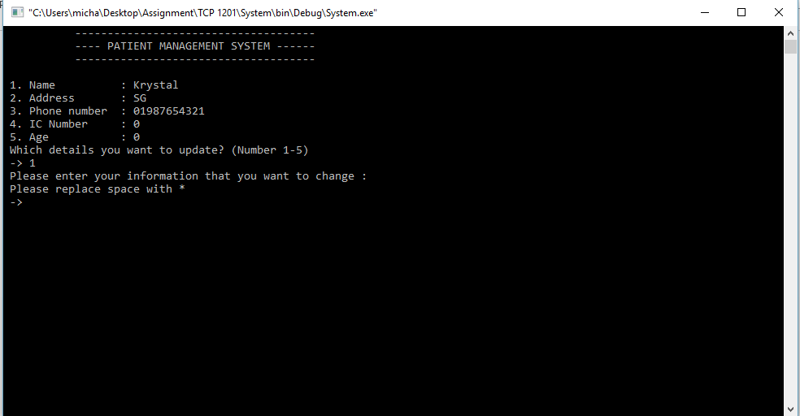

When user choose 1, user are required to type the information that user want to change.

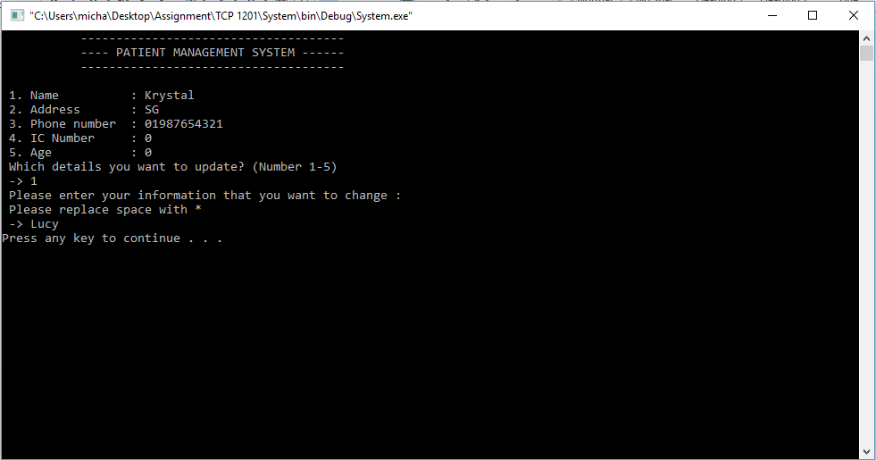

After user type the information, user are required to press any key to continue. After user press any key, program will go back to existing patient page.

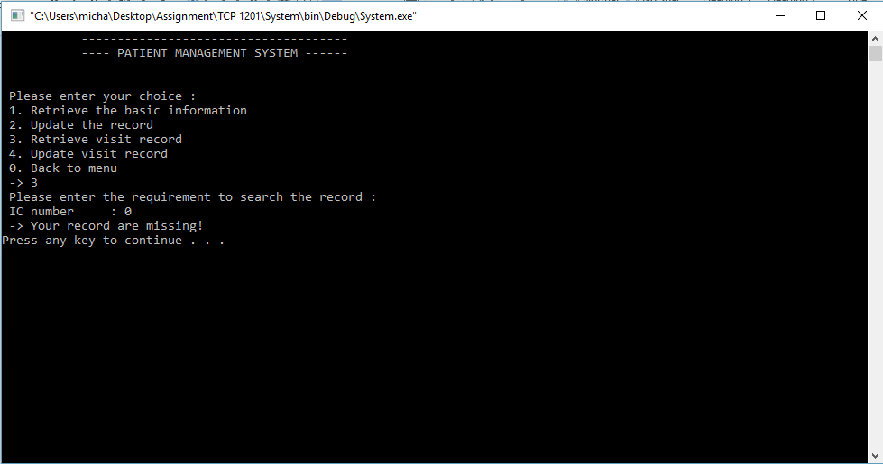

User may retrieve the visit record by enter choice 3. After user enter choice 3, user are required to type IC number to check the record. The new user are don’t have any visit record so the picture above show that your record are missing.

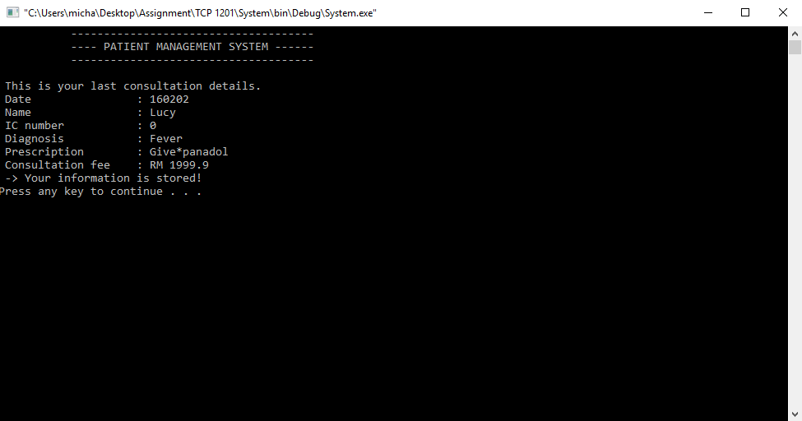

After user type the visit record into the system, system will show again the consultation details. Then after that it will go back to existing patient page.

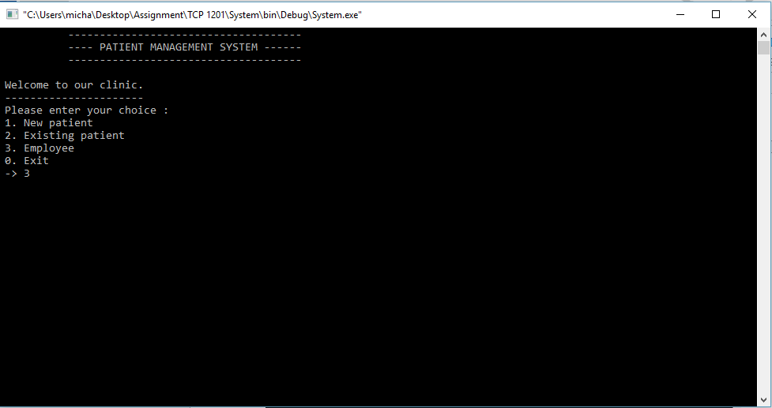

Another part is this program do have a feature is employee.

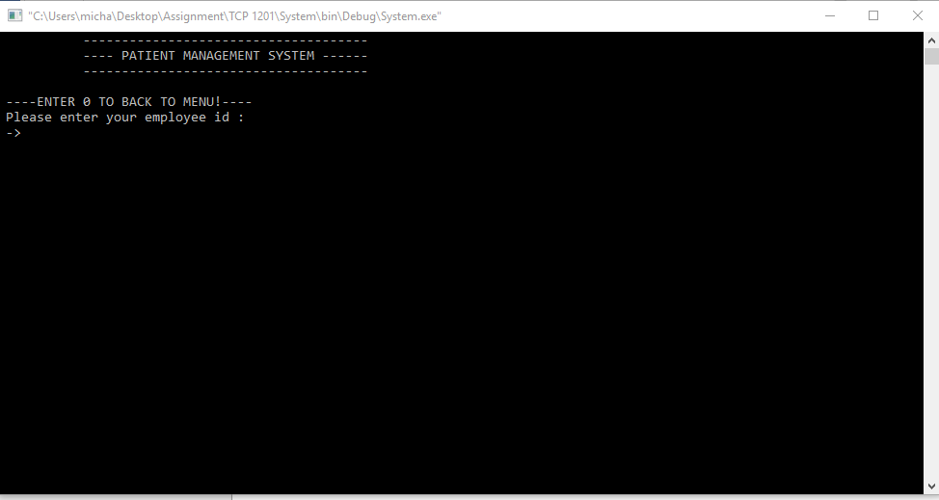

After enter the choice 3, user are required to type the employee id, otherwise user are not allow to enter employee part.

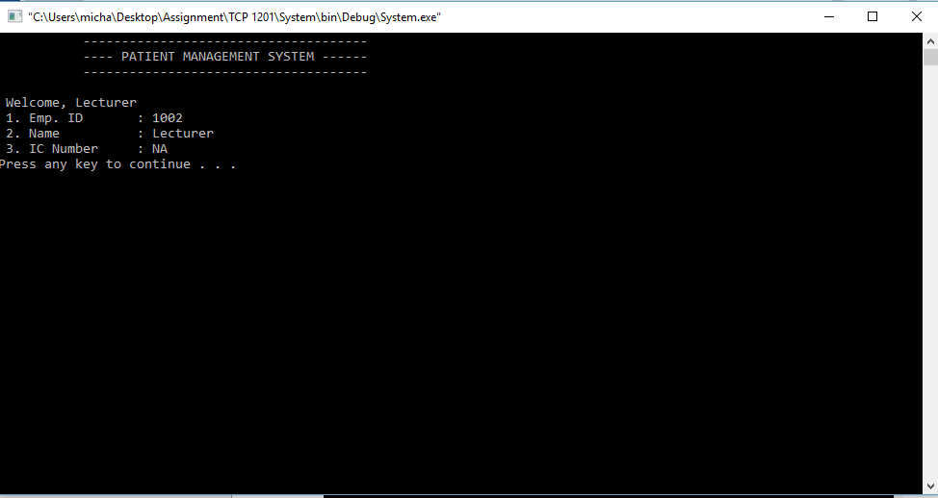After user enter correct employee id, it will show as above.

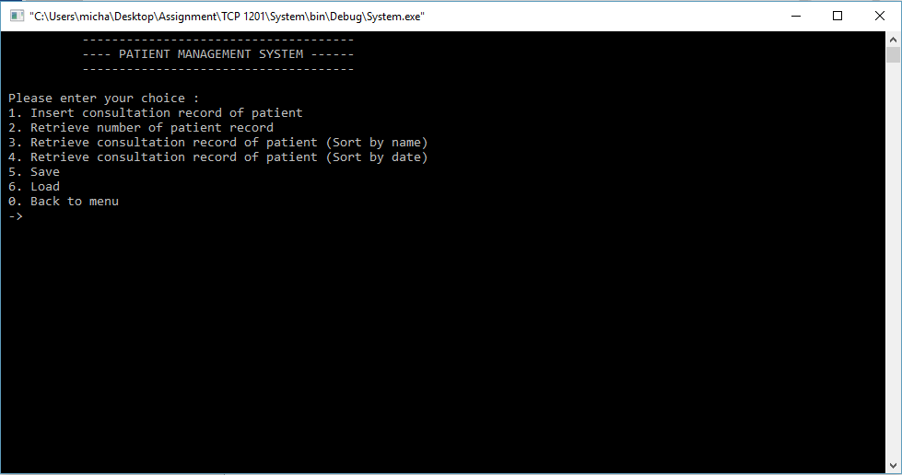

After user press any key, it will jump to this page as above.

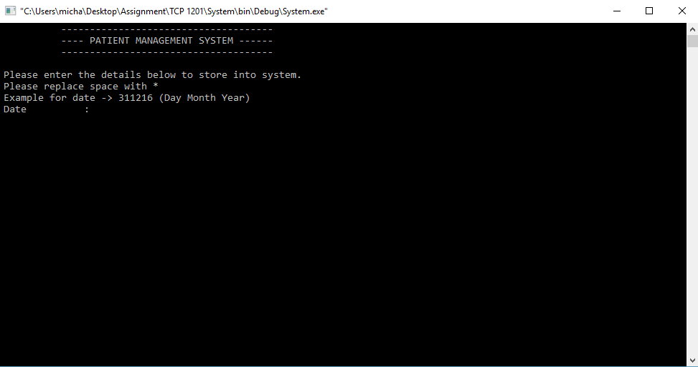

When user enter choice 1, user are required to type the daily consultation details.

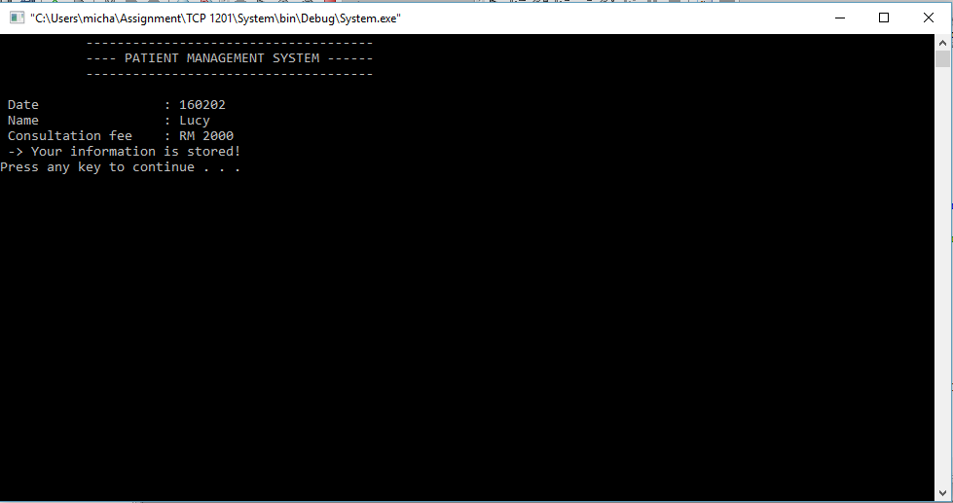

After user done enter, it will show again the details that user type. User will go back to menu after press any key.

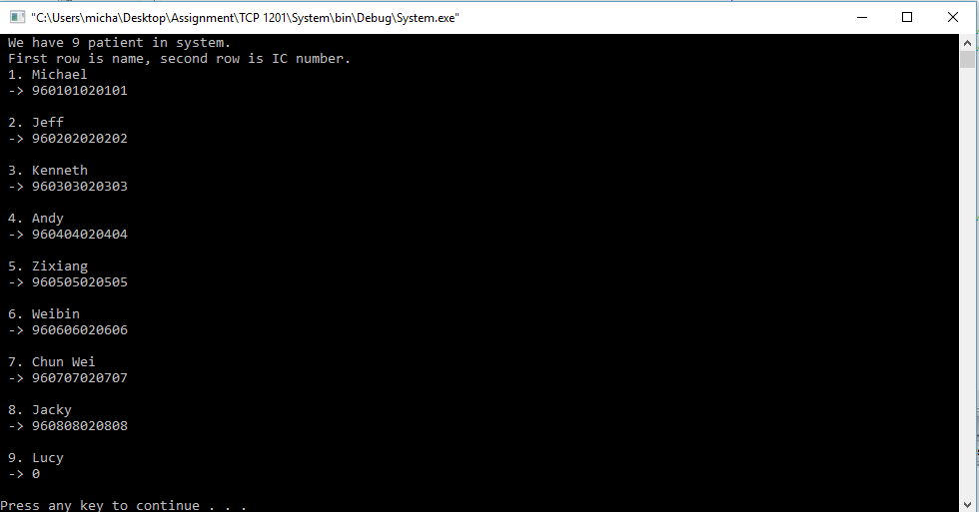

After user enter the choice 2 of the employee menu, it will show all the patient name and IC number.

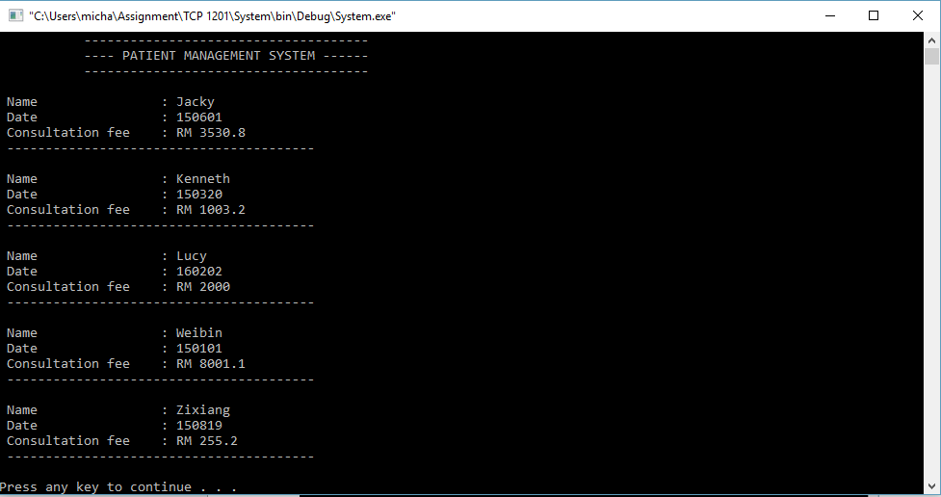

This page as above will come out after user enter choice 3 in employee page.

This is the all consultation record and sort by name.

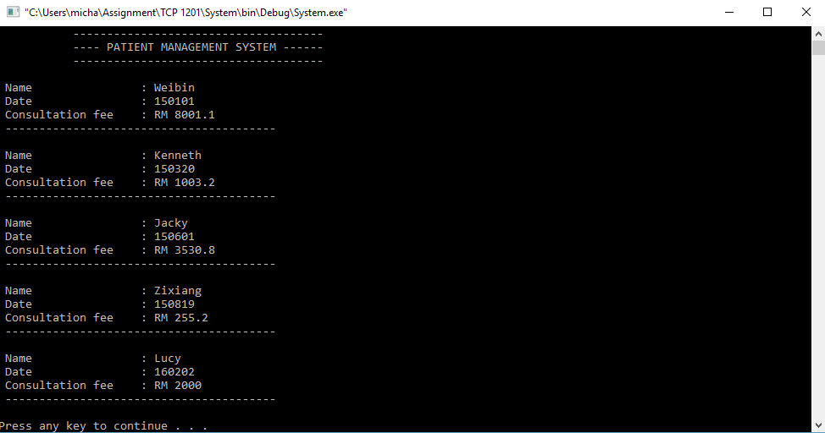

After user enter choice 4 in employee page, this page will show all the consultation record and it is sorted by date.

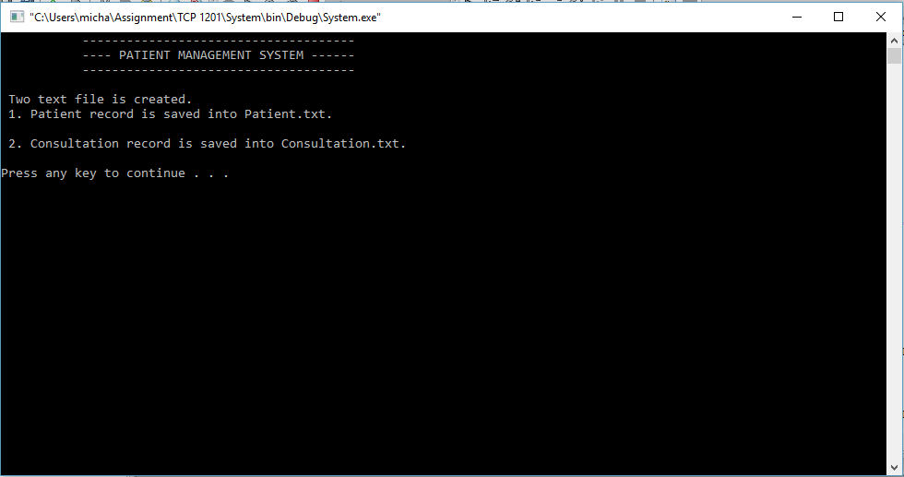

User will saw this after user choose 5 to save the record.

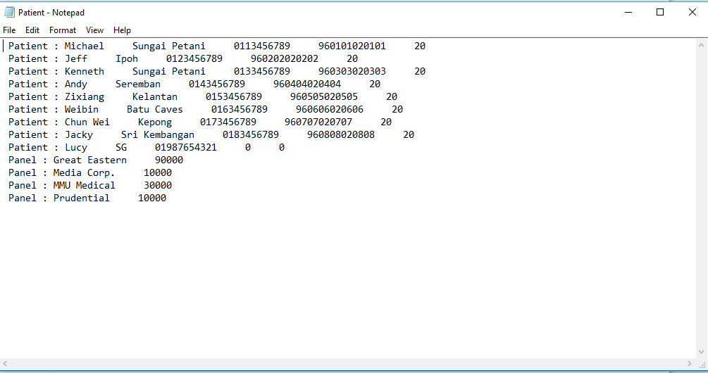

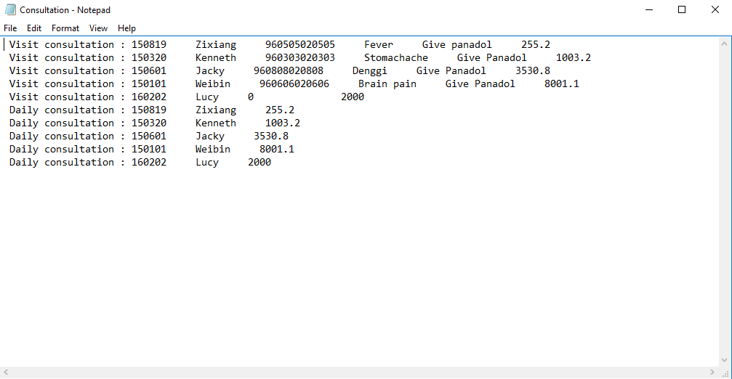

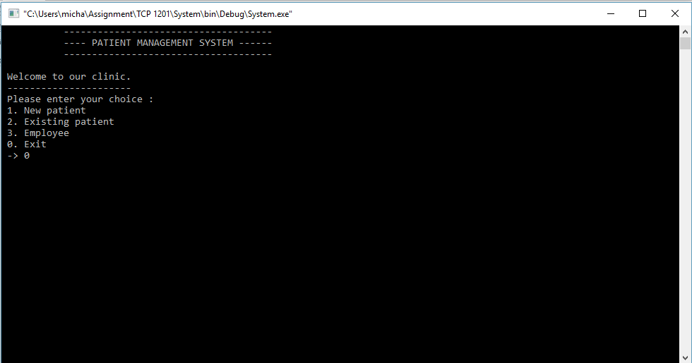

At the end, user may press 0 to exit the program.